The Cardiopulmonary Benefits of Bikram Yoga

1. A minimum of 30 adult males and females, 18 years of age or older and considered at low risk for atherosclerotic cardiovascular disease based on the American College of Sports Medicine (ACSM) guidelines (ACSM, 2010) will be used as test subjects. Prior physical activity levels or experience with yoga will not be a criterion for inclusion in this study. This study is intended for apparently healthy adults exhibiting no signs or symptoms suggestive of heart, metabolic (diabetes), and pulmonary disease. A comprehensive health-history survey (see appendix A) will be administered to identify volunteers who: 1) have heart disease, diabetes, chronic obstructive pulmonary disease (including severe asthma), 2) have experienced recent musculoskeletal injuries, 3) are pregnant (or think they are pregnant); and 4) have more than one risk factor for atherosclerotic cardiovascular disease. Any subject that falls into one or more of these categories will be excluded from the study.
2. Subjects will be recruited from a 60-day program offered by Pure Bikram Yoga in Austin, Texas. The primary investigator will provide all particpants with a written consent form outlining the procedures for the laboratory tests. Informed consent will be obtained from all participants prior to enrollment into the study. It is important to note that the subjects have voluntarily paid and signed up for the 60-day program. I am merely investigating the pre and post-changes.
3. Subjects will be asked to participate in testing on two separate occasions: a) before starting the 60-day program; and b) within one week of completing the 60-day program. Before each test, subjects will be asked to: 1) drink plenty of fluids over the 24-hour period preceding the test; 2) avoid food, tobacco, nicotine, alcohol, and caffeine for at least 3 hours prior to the test; 3) avoid strenuous physical activity the day of the test; and 4) get at least 6 hours of sleep the night before the test (ACSM, 2010) (see appendix B).

During pre-testing, subjects will complete a consent form (see appendix C) and a short survey (see appendix D) and be measured for height and weight (in light clothing, but without shoes) using a calibrated physician’s scale (Detecto Scale Co., Jerico, New York). After 10 minutes of seated rest, blood pressure (Baumanometer Standby Model, W.A. Baum Co, Inc., Copiague, NY) and resting heart rate (Polar FT4 heart rate monitor, Finland) will be measured while the subject is in a seated position. Then, participants will undergo a battery of pulmonary function tests to measure Forced Vital Capacity (FVC), Forced Expiratory Volume in the first second (FEV1.0), Peak Expiratory Flow Rate (PEFR), Maximum Voluntary Ventilation (MVV), Maximum Expiratory Pressure (MEP), and Maximum Inspiratory Pressure (MIP). FVC, FEV1.0, and PEFR will be administered in the seated position to minimize any risk of fainting according to the guidelines of the American Thoracic Society/European Respiratory Society (ATS/ERS) guidelines (Miller et al., 2005). MVV will be administered in the standing position after 3 good FVC, FEV1.0, and PEFR trials have been attained (Miller et al., 2005). Prior to both tests, the administrator will demonstrate the technique for the subject. A nose clip will be placed on the subject and the subject will be instructed to make an airtight seal around the hand-held spirometer and not to block the spirometer with the tongue. The subject will perform at least three normal tidal breaths. When ready, the administrator will tell the subject to begin. For FVC, FEV1.0, and PEFR testing, subjects will be instructed to inhale as quickly and deeply as possible followed by a forceful exhalation for at least 6 seconds. The subject will be instructed to maintain an upright posture. There will be one to two minutes of rest between each trial and the best trial will be collected for data. For the MVV test, subjects will be instructed to inhale and exhale as quickly and rapidly as possible for 15 seconds. The best 12 seconds of data will be recorded. Two minutes of rest will be given between trials.

MEP and MIP will be measured next with the subject in a seated position according to the ATS/ERS Statement on Respiratory Muscle Testing (ATS/ERS, 2002). The test administrator will first demonstrate how the subject will perform the MIP and MEP tests. The subject will make an airtight seal around the Vacumed respiratory force pressure gauge (model number 1505-120, Ventura, CA). MIP will be recorded from residual volume and MEP will be recorded starting at total lung capacity (TLC). Subjects will need to sustain each effort for at least 1 second. One to two minutes of rest will be given between trials and the maximum value of three maneuvers that vary less than 5% will be recorded. Throughout all testing, enthusiastic coaching will be given.

Maximal oxygen consumption (VO2max) and maximal heart rate (HRmax) will be measured using a graded exercise test on a Monark Ergomedic 894E stationary bike. After a 3-5 minute warm-up period, the exercise test will begin at 60 W and the subjects will maintain a 60 revolution•min-1 (rpm) pace. Every two minutes, work will be increased by 30 W for males and 15 W for females. Heart rate will be measured by the Polar FT4 heart rate monitor. Expired air will be analyzed throughout the tests with a PARVO Medics metabolic analyzer (Salt Lake City, UT). VO2, VCO2, and respiratory exchange ratio (RER) will be determined from 60-second averages. Heart rate will be recorded at the end of each minute. Calibration will be performed before each test using a certified gas mixture (O2= 16% and CO2= 4%, Scott Medical Products, Plumsteadville, PA). Peak VO2 will be considered VO2max if either VO2 levels off with an increase in workload or age-predicted maximal heart rate (206.9- (.67*age)) is achieved and the RER exceeds 1.15 (McArdle, Katch, & Katch, 2010). If VO2max is not achieved, then subjects will be asked to return 48 hours later for re-testing. These procedures will be repeated within one week of the end of the 60-day program.

All subjects will complete 60-days of Bikram Yoga between the dates of January 1st and March 13th at Pure Bikram Yoga, a studio certified by the Bikram Yoga College of India. Each 90-minute session will consist of a set series of 26 postures performed in a heated (105°F) and humidified (40% relative humidity) studio. All classes will be taught by a Bikram yoga certified instructor. The first 60 minutes of class will consist of standing and balance poses, and the last 30 minutes will involve seated poses. For a detailed description of all poses practiced during Bikram yoga, refer to Bikram’s Beginning Yoga Class (Choudhury, 2000). All postures will be performed twice.

Attendance will be tracked using a sign-in sheet (see Appendix E). To be included in final data analysis, subjects must attend a minimum of 48 classes (80% attendance). The subjects’ physical activity and diet outside of Bikram yoga will not be monitored, but they will be asked to maintain diet and refrain from participating in any other forms of exercise.

1. Injuries to healthy subjects during exercise testing are uncommon. However, the chance for injury is acknowledged and precautions will be taken to prevent injuries. There exists the possibility of adverse changes during the exercise testing. These changes could include abnormal blood pressure, fainting, disorders of heart rhythm, stroke, and very rare instances of heart attack or even death. There is the possibility of dizziness and nausea immediately following the exercise performances. Also, there is the possibility of muscle strain. Muscle soreness may be present for 24-48 hours following the exercise tests.
2. A comprehensive health-history survey (see appendix A) will be administered to identify volunteers who: 1) have heart disease, diabetes, chronic obstructive pulmonary disease (including severe asthma), 2) have experienced recent musculoskeletal injuries, 3) are pregnant (or think they are pregnant); and 4) have no more than one risk factor for atherosclerotic cardiovascular disease. This questionnaire will be completed and reviewed before the first day of testing. If a medical emergency occurs during testing, emergency services will be contacted. The primary investigator will assist with all emergency situations until EMS arrives on scene. If a minor emergency occurs, the laboratory is located in the same building as the Athletic Training Lab with on-site accredited Athletic Trainers available to provide support if needed. The primary investigator also has certification in CPR and has experience working with research conducted by other professors in the Health and Human Performance Department at Texas State University.
3. Participation in the program will help the subject gain knowledge of their exercise capacity in relation to the general population and a better understanding of their level of fitness for certain sports and recreational activities. This knowledge may aid in planning a future physical conditioning program or in evaluating the effects of recent physical activity habits. The subject will also gain a better understanding of their pulmonary ventilation and be able to see the improvements after yoga training. The results of this study may also help promote Bikram yoga in the medical/exercise community if we find that Bikram yoga significantly improves aerobic fitness and/or pulmonary function.
4. No compensation will be given for participation.
5. Although there is a chance for injury involved in all exercise testing, the potential benefits of this study may help other members of the general public decide if Bikram yoga is an effective exercise.
6. All testing and training will take place at Pure Bikram Yoga in Austin, Texas. Appendix F shows the approval letter from Pure Bikram Yoga.
7. This study will help fulfill the requirements to attain a master’s degree in Exercise Science at Texas State University-San Marcos. This project is sponsored by Dr. Lisa Lloyd in the Department of Health and Human Performance.
8. Appendix G
9. Not applicable
10. The results of this study will be available to the Texas State University-San Marcos community. If published, the results will become available to the public.

References

American College of Sports Medicine. (2010). *Guidelines for Exercise Testing and Prescription* (8th ed.). Philadelphia: Lippincott, Williams and Wilkins.

American Thoracic Society/European Respiratory Society. (2002). ATS/ERS statement on respiratory muscle testing. *American Journal of Respiratory and Critical Care Medicine*, 166, 518-624. doi: 10.1164/rccm.166.4.518

Choudhury, B. (2000). *Bikram’s beginning yoga class* (2nd ed.). New York: Penguin Putnam Inc.

McArdle, W.D., Katch, F.I., & Katch, F.I. (2010). Individual differences and measurement of energy capacities. *Exercise physiology: Nutrition, energy, and human performance* (7th ed.) (pp. 225-247). Baltimore, MD: Lippincott Williams & Wilkins.

Miller, M.R., Hankinson, J., Brusasco, V., Burgos, F., Casaburi, R., Coates, A., et al. (2005). Standardisation of Spirometry. *European Respiratory Journal* 26: 319–338. doi: 10.1183/09031936.05.00034805

**Appendix A- Medical Health Appraisal**

**Medical Health Appraisal**

|  |  |  |
| --- | --- | --- |
| Do you have a physician in town? **Name: Phone Number:** | | |
|  | | |
| **Yes** | **No** | **History of Heart Disease – Have you experienced:** |
| 🔿 | 🔿 | A heart attack? If so, when? |
| 🔿 | 🔿 | Heart surgery? If so, when? |
| 🔿 | 🔿 | Cardiac catherization? If so, when? |
| 🔿 | 🔿 | Coronary angioplasty (PTCA)? If so, when? |
| 🔿 | 🔿 | Pacemaker/implantable cardiac defibrillator/rhythm disturbance? If so, when? |
| 🔿 | 🔿 | Heart valve disease? If so, when was it diagnosed? |
| 🔿 | 🔿 | Heart failure? If so, when? |
| 🔿 | 🔿 | Heart transplantation? If so, when? |
| 🔿 | 🔿 | Congenital heart disease? If so, when was it diagnosed? |
|  | | |
| **Yes** | **No** | **Current Health Status** |
| 🔿 | 🔿 | Do you have diabetes? If so, when was it diagnosed? |
| 🔿 | 🔿 | Lung disease? If so, when was it diagnosed? |
| 🔿 | 🔿 | Asthma? If so, when was it diagnosed? |
| 🔿 | 🔿 | Kidney disease? If so, when was it diagnosed? |
| 🔿 | 🔿 | Liver disease? If so, when was it diagnosed? |
| 🔿 | 🔿 | If you are a female, are you pregnant or do you think that you might be pregnant? |
|  | | |
| **Yes** | **No** | **Symptoms – Do you:** |
| 🔿 | 🔿 | Experience chest discomfort with exertion? |
| 🔿 | 🔿 | Experience unreasonable breathlessness or unusual fatigue at rest, with mild exertion, or during usual activities? |
| 🔿 | 🔿 | Experience dizziness, fainting, or blackouts? |
| 🔿 | 🔿 | Take heart medications? If so, what kind? |
| 🔿 | 🔿 | Experience difficulty breathing when lying flat or when asleep? |
| 🔿 | 🔿 | Experience ankle swelling? |
| 🔿 | 🔿 | Experience forceful or rapid heartbeats? |
| 🔿 | 🔿 | Experience numbness in legs or arms from time to time? |
| 🔿 | 🔿 | Have a known heart murmur? |
|  | | |
| **If you answered “No” to all questions listed above, then proceed to next page. If you answered “yes” to any of the questions listed above, then we recommend that you receive approval from your healthcare provider before participating in the research.** | | |

|  |  |  |  |
| --- | --- | --- | --- |
|  | | | |
| **Yes** | **No** | **Cardiovascular risk factors:** | |
| 🔿 | 🔿 | Do you smoke or have you quit smoking within the last 6 months? | |
| 🔿 | 🔿 | Have you been diagnosed with high blood pressure or do you take blood pressure medication? (Mark “Yes” if you **do not** know your blood pressure). | |
| 🔿 | 🔿 | Have you been diagnosed with high cholesterol levels, or do you take cholesterol-lowering medication? (Mark “Yes” if you **do not** know your cholesterol.) | |
| 🔿 | 🔿 | Has a close blood relative experienced a heart attack, heart or blood vessel surgery, or sudden death from a heart attack or stroke before age 55 (father, brother, or son) or age 65 (mother, sister, or daughter)? | |
| 🔿 | 🔿 | Have you been diagnosed with high blood sugar, or do you take medicine to control your blood sugar? (**Leave blank** if you do not know anything about your blood sugar levels.) | |
| 🔿 | 🔿 | Are you physically inactive (i.e., do you get less than 30 minutes of physical activity on at least 5 days per the week)? | |
| 🔿 | 🔿 | If you are a male, are you 45 years or older? If you are a female, are you 55 years or older (or have you had a hysterectomy or are you postmenopausal)? | |
| 🔿 | 🔿 | Is your Body Mass Index 30 kg/m2 or higher or are you at least 20 pounds overweight? (Mark “Yes” if you *think* you are overweight/obese.) | |
|  | | | |
| **Yes** | **No** | **Other health issues that may warrant physician approval before engaging in physical activity.** | |
| 🔿 | 🔿 | Have you ever been told not to exercise by a health care provider? | |
| 🔿 | 🔿 | Are you pregnant or think you might be pregnant? | |
| 🔿 | 🔿 | Do you have problems with your muscles, bones, or joints? | |
|  | | | |
| 🔿 | 🔿 | Are you taking prescription medications? If so, please list: | |
|  | | **Medication** | **Dosage** |
|  | |  |  |
|  | |  |  |
|  | |  |  |
|  | |  |  |

**I certify that the information included on this form is correct.**

________________ ____________________________________________

Date Signature of Participant

________________ ____________________________________________

Date Signature of Primary Investigator

|  |
| --- |
| **(Office Use Only) Risk Status:** 🔿 **1. Low** 🔿 **2. Moderate** 🔿 **3. High** 🔿 **Diabetes** 🔿 **Heart Disease** 🔿 **Lung Disease** 🔿 **Kidney Disease** 🔿 **Liver Disease** 🔿 **Pregnant** |

**Appendix B- Pre-Test Instructions**

The Cardiopulmonary Benefits of Bikram Yoga

Research Investigation

Pre-test Instructions

Before you participate in any fitness testing, you need to first be made aware of what to expect, what to do before testing, and what to wear to the test.

**What to expect?**

When you arrive, you will be introduced to the primary investigator and any questions you may have will be answered. After 10 minutes of seated rest, your heart rate and blood pressure will be measured. Next, you will be taken through a battery of pulmonary tests that will require you to maximally exhale and inhale. Finally, a maximal aerobic exercise test will be administered. You will be asked to ride a stationary bike at an increasing workload until fatigue.

**What to wear?**

You will need to wear a t-shirt, workout shorts or pants, and comfortable exercise shoes with good support. We also recommend that female clients wear a sports bra.

**What to do before testing?**

1. You should refrain from consuming food, alcohol, caffeine or using tobacco and nicotine products at least 3 hours before the test.
2. You should be well rested before the test so make sure to get at least 6 hours of sleep the night before the test.
3. Avoid any exercise the day of the test.
4. Drink plenty of fluids during the 24-hour period prior to the test.

What to bring?

A light snack and/or carbohydrate beverage (such as, Gatorade). Sometimes, clients experience fatigue and/or low blood sugar when performing a battery of fitness tests.

If you have any questions, please call Allison Abel at 281-685-2601 or e-mail her at [aa1229@txstate.edu](mailto:CarolynClay@txstate.edu).

**Appendix C- Consent Form**

|  |  |
| --- | --- |
| **Consent Form** | |
| **Project Title:** | The Cardiopulmonary Effects of Bikram Yoga |
| **IRB Number:** | 2010Q9888 |
| **Principal Investigator:** | Allison Abel, Graduate Student, 281-685-2601, [aa1229@txstate.edu](mailto:aa1229@txstate.edu) |
| **Professor of Record:** | Lisa Lloyd, PhD, Associate Professor, 512-245-8358, LisaLloyd@txstate.edu |

**INTRODUCTION**. You are being asked to participate in a research study. This study is being completed as part of my thesis requirements for graduation. This form provides you with information regarding the research being conducted. You have been asked to participate in this study because you have signed up to complete the 60-day Bikram Yoga program at Pure Bikram Yoga in Austin, Texas. Please read this form and ask any questions you may have regarding participation in this study. Participation is entirely voluntary. You will be tested at Pure Bikram Yoga in Austin, Texas. Read the information below and ask questions about anything you do not understand prior to deciding whether or not to participate.

**PURPOSE OF THIS RESEARCH STUDY**. The purpose of this research is to determine the effects of 60-days of Bikram yoga practice on heart health and lung capacity in healthy adults.

**PROCEDURES**. If you agree to participate in this study, you will be expected to visit with researchers at 2 different times between December and March.

1. During your first visit, you will meet with a researcher for about 1 hour and you will:

* Fill out a form asking you some questions about your age, how you feel about exercise, and how much you exercise (*Note*. You can choose not to answer any question on the form).
* Be measured for body weight, height. You will not be required to remove any clothing except for your shoes. We ask, however, that you dress in lightweight clothing.
* Rest in a lying position for 5 minutes in a dimly lit room and then have your resting blood pressure and resting heart rate measured.
* Engage in lung function tests, which require you to inhale and exhale as hard as you can into a mouthpiece.
* Complete an exercise test on a stationary bicycle to determine your aerobic endurance capacity (maximal oxygen consumption).

1. During the second visit, which will be within 1 week of the completion of your 60-day yoga training, you will meet with a researcher for about 1 hour and these procedures will be repeated.

**POTENTIAL RISKS OR DISCOMFORTS.** Injuries to healthy subjects during exercise testing are uncommon. However, the chance for injury is acknowledged and precautions will be taken to prevent injuries. There exists the possibility of adverse changes during the exercise testing. These changes could include abnormal blood pressure, fainting, disorders of heart rhythm, stroke, and very rare instances of heart attack or even death. There is the possibility of dizziness and nausea immediately following the exercise performances. Also, there is the possibility of muscle strain. Muscle soreness may be present for 24-48 hours following the exercise tests. Please note that you are responsible for paying your own medical bills if you seek/receive medical health services due to a complication associated with your participation in this research study.

**POSSIBLE BENEFITS.** Your participation in this research will help you gain knowledge of your exercise capacity in relation to the general population and a better understanding of your level of fitness for certain sports and recreational activities. This knowledge may aid you in planning a future physical conditioning program or in evaluating the effects of recent physical activity habits. You will also gain a better understanding of your pulmonary ventilation and be able to see whether improvements occurred as a result of the 60-day Bikram yoga training program. If you are interested in learning the results of the study, contact me at 281-685-2601 upon the completion of the study and I will send you a summary of the findings. The results of this study may also help promote Bikram yoga in the medical/exercise community if we find that Bikram yoga significantly improves aerobic fitness and/or pulmonary function.

**CONFIDENTIALITY**. Your personal information will be kept confidential. Your information will be kept in a locked cabinet in Allison Abel’s office at Texas State University-San Marcos and destroyed after three years. The professors and staff will use this information for research, but your name will not be given out in any reports. The information gathered will never be revealed to anyone other than the researchers and will only be reported in aggregate, that is, as part of an average score.

**TERMINATION OF RESEARCH STUDY.** You are free to decide if you would like to take part in this research. If you choose not to take part, it will not affect your right to seek other services from any agencies, institutions, or entities involved with this research project. You may quit at anytime. If you decide to stop participating in the study, please notify the researchers of your decision.In addition, the researchers may end your participation in the study without your consent if they believe that you may be in danger.

**AVAILABLE SOURCES OF INFORMATION**

**For questions about this study call:**

Principal Investigator: Allison Abel  
Phone Number: 281-685-2601

**For questions you may have about your rights as a research subject call:**

Institutional Review Board Chair: Dr. Jon Lasser Compliance Specialist: Ms. Becky Northcut

Phone Number: 512-245-3413 Phone Number: 512-245-2102

**AUTHORIZATION**. “I have read and understand this consent form, and I agree to participate in this research study. I understand that I have received a copy of this form. I voluntarily choose to participate, but I understand that my consent does not take away any legal rights in the case of negligence or other legal fault of anyone who is involved in this study. I further understand that nothing in this consent form is intended to replace any applicable Federal, state, or local laws. I also understand that I may withdraw from this study at any time without penalty.”

|  |  |  |  |
| --- | --- | --- | --- |
| **Participant Name (Printed):** |  | | |
| **Participant Signature:** |  |  |  |
| **Date:** |  |  |  |
| **Principal Investigator (Signature):** |  |  |  |
| **Date:** |  |  |  |

**Appendix D- Survey**

The Cardiopulmonary Benefits of Bikram Yoga

**Part 1**

This is for participants who have NEVER previously engaged in Bikram Yoga

|  |  |
| --- | --- |
| 1. | How many times each week do you do VIGOROUS leisure-time physical activities for AT LEAST 10 MINUTES that cause HEAVY sweating or LARGE increases in breathing or heart rate?  _____ times per week |
| 2. | About how long do you do these vigorous leisure-time physical activities each time?  _____ minutes each time |
| 3. | How many times each week do you do LIGHT or MODERATE leisure-time physical activities for AT LEAST 10 MINUTES that cause ONLY LIGHT sweating or a SLIGHT to MODERATE increase in breathing or heart rate?  _____ times per week |
| 4. | About how long do you do these light or moderate leisure-time physical activities each time?  _____ minutes each time |
| 5. | How many times each week do you do leisure-time physical activities specifically designed to STRENGTHEN your muscles such as lifting weights or doing calisthenics?  _____ times per week |
| 6. | About how long do you do these strengthening leisure-time physical activities each time?  _____ minutes each time |

**Part 2**

This section is for people who have previously participated in Bikram Yoga

|  |  |
| --- | --- |
| 7. | How long have you been practicing Bikram Yoga? _______________  ­­­­­­­­­­­­ |
| 8. | On average, how many days per week do you attend Bikram Yoga classes?  ­­­­_______ times per week |
| 9. | Do you engage in any other exercise programs? _______Yes _______No  (if yes, please complete Part 2; include ONLY the outside activity and NOT Bikram yoga in Part 1) |

**Thanks for helping with the survey. ☺**

**Appendix E- Attendance Sheet**

|  |  |  |
| --- | --- | --- |
| **Research Sign-in Sheet** | | |
| **The Cardiopulmonary Effects of Bikram Yoga** | | |
|  | Name | Date |
| 1 |  |  |
| 2 |  |  |
| 3 |  |  |
| 4 |  |  |
| 5 |  |  |
| 6 |  |  |
| 7 |  |  |
| 8 |  |  |
| 9 |  |  |
| 10 |  |  |
| 11 |  |  |
| 12 |  |  |
| 13 |  |  |
| 14 |  |  |
| 15 |  |  |
| 16 |  |  |
| 17 |  |  |
| 18 |  |  |
| 19 |  |  |
| 20 |  |  |
| 21 |  |  |
| 22 |  |  |
| 23 |  |  |
| 24 |  |  |
| 25 |  |  |
| 26 |  |  |
| 27 |  |  |
| 28 |  |  |
| 29 |  |  |
| 30 |  |  |
| 31 |  |  |
| 32 |  |  |
| 33 |  |  |
| 34 |  |  |
| 35 |  |  |
| 36 |  |  |
| 37 |  |  |
| 38 |  |  |
| 39 |  |  |
| 40 |  |  |
| 41 |  |  |
| 42 |  |  |
| 43 |  |  |
| 44 |  |  |
| 45 |  |  |
| 46 |  |  |
| 47 |  |  |
| 48 |  |  |
| 49 |  |  |
| 50 |  |  |
| 51 |  |  |
| 52 |  |  |
| 53 |  |  |
| 54 |  |  |
| 55 |  |  |
| 56 |  |  |
| 57 |  |  |
| 58 |  |  |
| 59 |  |  |
| 60 |  |  |
| 61 |  |  |
| 62 |  |  |
| 63 |  |  |
| 64 |  |  |
| 65 |  |  |
| 66 |  |  |
| 67 |  |  |
| 68 |  |  |
| 69 |  |  |
| 70 |  |  |

**Appendix F- Approval Letter from Pure Bikram Yoga**

**Appendix G- Approval Letter from Committee Chair**

To whom it may concern,

Please accept this e-mail as an indication of my support of Ms. Allison Abel's thesis/research project. I, as well as the other thesis committee members, have read her proposal and believe that it is a strong research project and that she will be taking every precaution necessary to ensure the safety of her subjects. If you have any questions, please do not hesitate to contact me at 5-8358 or [LL12@txstate.edu](mailto:LL12@txstate.edu).

Lisa Lloyd, Ph.D.

Exercise and Sports Science Division

Department of Health and Human Performance

**Appendix H- Flyer to Recruit Subjects for Testing**

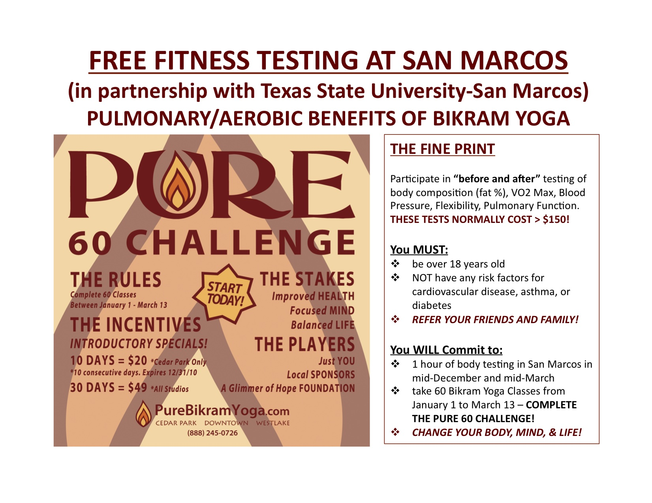

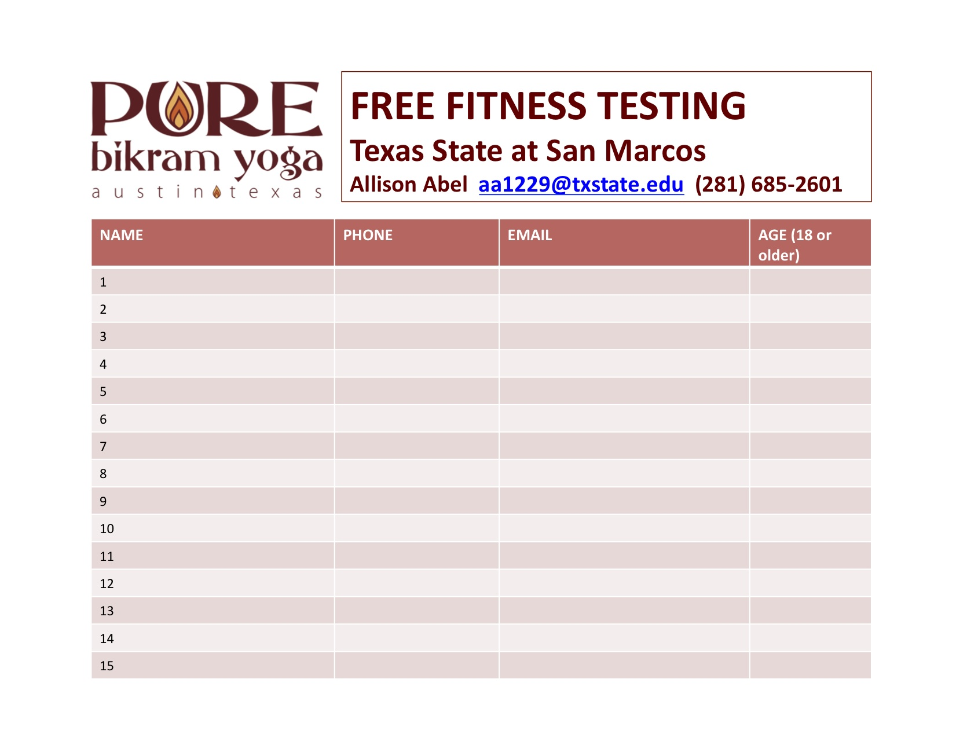

**Appendix I- Methods Section of Proposal**

Methods

Subjects

A minimum of 30 adult males and females will be recruited from a 60-day program offered by Pure Bikram Yoga in Austin, Texas. These subjects will be 18 years of age or older and will be considered at low risk for atherosclerotic cardiovascular disease based on the American College of Sports Medicine (ACSM) guidelines (ACSM, 2010). Experience with yoga will not be a criterion for inclusion in this study, as this study will also determine whether yoga experience as well as fitness level will have an impact on the cardiorespiratory effects of Bikram yoga. A written consent form outlining the procedures for the laboratory tests will be provided to all participants and informed consent will be obtained from all participants prior to enrollment into the study. Before this study begins, a proposal will be submitted to the Institutional Review Board for approval of the procedures.

This study is intended for apparently healthy adults exhibiting no signs or symptoms suggestive of heart, metabolic (diabetes), and pulmonary disease. A comprehensive health-history survey will be administered to identify volunteers who: 1) have heart disease, diabetes, chronic obstructive pulmonary disease (including severe asthma), 2) have experienced recent musculoskeletal injuries, 3) are pregnant (or think they are pregnant); and 4) have no more than one risk factor for atherosclerotic cardiovascular disease. This questionnaire will be completed and reviewed before the first day of testing.

Procedures

Subjects will be asked to participate in testing on two separate occasions: a) before starting the 60-day program; and b) within one week of completing the 60-day program. Before each test, subjects will be asked to: 1) drink plenty of fluids over the 24-hour period preceding the test; 2) avoid food, tobacco, nicotine, alcohol, and caffeine for at least 3 hours prior to the test; 3) avoid strenuous physical activity the day of the test; and 4) get at least 6 hours of sleep the night before the test (ACSM, 2010).

During pre-testing, subjects will complete a consent form and be measured for height and weight (in light clothing, but without shoes) using a calibrated physician’s scale (Detecto Scale Co., Jerico, New York). After 10 minutes of seated rest, blood pressure (Baumanometer Standby Model, W.A. Baum Co, Inc., Copiague, NY) and resting heart rate (Polar FT4 heart rate monitor, Finland) will be measured while the subject is in a seated position. Then, participants will undergo a battery of pulmonary function tests to measure Forced Vital Capacity (FVC), Forced Expiratory Volume in the first second (FEV1.0), Peak Expiratory Flow Rate (PEFR), Maximum Voluntary Ventilation (MVV), Maximum Expiratory Pressure (MEP), and Maximum Inspiratory Pressure (MIP). FVC, FEV1.0, and PEFR will be administered in the seated position to minimize any risk of fainting according to the guidelines of the American Thoracic Society/European Respiratory Society (ATS/ERS) guidelines (Miller et al., 2005). MVV will be administered in the standing position after 3 good FVC, FEV1.0, and PEFR trials have been attained (Miller et al., 2005). Prior to both tests, the administrator will demonstrate the technique for the subject. A nose clip will be placed on the subject and the subject will be instructed to make an airtight seal around the hand-held spirometer and not to block the spirometer with the tongue. The subject will perform at least three normal tidal breaths. When ready, the administrator will tell the subject to begin. For FVC, FEV1.0, and PEFR testing, subjects will be instructed to inhale as quickly and deeply as possible followed by a forceful exhalation for at least 6 seconds. The subject will be instructed to maintain an upright posture. There will be one to two minutes of rest between each trial and the best trial will be collected for data. For the MVV test, subjects will be instructed to inhale and exhale as quickly and rapidly as possible for 15 seconds. The best 12 seconds of data will be recorded. Two minutes of rest will be given between trials.

MEP and MIP will be measured next with the subject in a seated position according to the ATS/ERS Statement on Respiratory Muscle Testing (ATS/ERS, 2002). The test administrator will first demonstrate how the subject will perform the MIP and MEP tests. The subject will make an airtight seal around the Vacumed respiratory force pressure gauge (model number 1505-120, Ventura, CA). MIP will be recorded from residual volume and MEP will be recorded starting at total lung capacity (TLC). Subjects will need to sustain each effort for at least 1 second. One to two minutes of rest will be given between trials and the maximum value of three maneuvers that vary less than 5% will be recorded. Throughout all testing, enthusiastic coaching will be given.

Maximal oxygen consumption (VO2max) and maximal heart rate (HRmax) will be measured using a graded exercise test on a Monark Ergomedic 894E stationary bike. After a 3-5 minute warm-up period, the exercise test will begin at 60 W and the subjects will maintain a 60 revolution•min-1 (rpm) pace. Every two minutes, work will be increased by 30 W for males and 15 W for females. Heart rate will be measured by the Polar FT4 heart rate monitor. Expired air will be analyzed throughout the tests with a PARVO Medics metabolic analyzer (Salt Lake City, UT). VO2, VCO2, and respiratory exchange ratio (RER) will be determined from 60-second averages. Heart rate will be recorded at the end of each minute. Calibration will be performed before each test using a certified gas mixture (O2= 16% and CO2= 4%, Scott Medical Products, Plumsteadville, PA). Peak VO2 will be considered VO2max if either VO2 levels off with an increase in workload or age-predicted maximal heart rate (206.9- (.67*age)) is achieved and the RER exceeds 1.15 (McArdle, Katch, & Katch, 2010a). If VO2max is not achieved, then subjects will be asked to return 48 hours later for re-testing. These procedures will be repeated within one week of the end of the 60-day program.

All subjects will complete 60-days of Bikram Yoga between the dates of January 1st and March 13th at Pure Bikram Yoga, a studio certified by the Bikram Yoga College of India. Each 90-minute session will consist of a set series of 26 postures performed in a heated (105°F) and humidified (40% relative humidity) studio. Bikram yoga is a standardized, trademarked program that requires all classes, regardless of instructor and studio, be conducted in exactly the same manner (Choudhury, 2000). All classes will be taught by a Bikram yoga certified instructor. The first 60 minutes of class will consist of standing and balance poses, and the last 30 minutes will involve seated poses. For a detailed description of all poses practiced during Bikram yoga, refer to Bikram’s Beginning Yoga Class (Choudhury, 2000). All postures will be performed twice.

Attendance will be tracked using a sign-in sheet. To be included in final data analysis, subjects must attend a minimum of 48 classes (80% attendance). The subjects’ physical activity and diet outside of Bikram yoga will not be monitored, but they will be asked to maintain diet and refrain from participating in any other forms of exercise.